The graph below shows the number of male chicks culled annually between different countries. The data used was taken between 2014-2020.
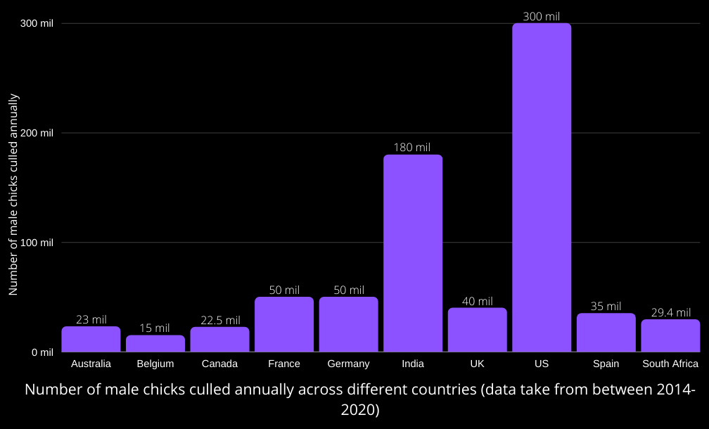
References for country’s figures/numbers:
Australia: RSPCA AUSTRALIA. 2020. "What happens to male chicks? Solving an animal welfare challenge. Available from: https://rspcaapproved.org.au/2020/08/27/csiro-helping-solve-one-australian-farmings-biggest-animal-welfare-challenges
Belgium: VILT vzw. 2020. "Eéndagshaantjes: zijn er alternatieven?" (in Dutch). Available from: https://vilt.be/nl/nieuws/eendagshaantjes-zijn-er-alternatieven.
Canada: Epp, M. 2016. “Hypereye: A game changer”. Available from: https://www.canadianpoultrymag.com/hypereye-a-game-changer-30033/.
France: Ohier, F. 2020. “Carrefour et Loué s'associent pour réduire le broyage des poussins males” (in French). Available from: https://www.franceinter.fr/economie/carrefour-et-loue-s-associent-pour-reduire-le-broyage-des-poussins-males.
Germany: Fisser, D. 2019. “Groko bricht Versprechen: Vergasung von männlichen Küken geht weiter” (in German). Available from: https://www.shz.de/regionales/schleswig-holstein/groko-bricht-versprechen-vergasung-von-maennlichen-kueken-geht-weiter-id26103487.html.
India: Saraswathy, M. 2014. “Unilever working to end the culling of male chicks”. Available from: https://www.business-standard.com/article/companies/unilever-working-to-end-the-culling-of-male-chicks-114100400651_1.html.
UK: Farmers Weekly. 2020. “No alternatives to culling day old male chicks… yet”. Available from: https://www.fwi.co.uk/livestock/poultry/layers/no-alternatives-to-culling-day-old-male-chicks-yet.
US: Brice-Saddler, M. 2020. “France says its poultry industry will stop shredding male chicks alive by 2022”. Available from: https://www.washingtonpost.com/science/2020/01/29/shredding-chicks-ban/.
Spain: Pérez, A, C. 2020. "El sacrificio de pollitos macho en España podría terminar en 2021 según el Ministerio de Agricultura" (in Spanish). Available from: https://www.cronicanorte.es/el-sacrificio-de-pollitos-macho-en-espana-podria-terminar-en-2021-segun-el-ministerio-de-agricultura/144696.
South Africa: South African Poultry Association. 2020. “Egg industry production report for March 2020”. Available from: http://www.sapoultry.co.za/pdf-statistics/egg-industry.pdf.

